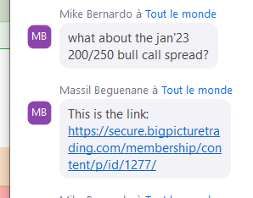

TRADING PLAN

Goals :
- Learn how to protect my portfolio 300,000 USD, rebalance it.
- Develop a small scale portfolio based upon Options, Commodities
Actual (23.06.2022): 35K USD
Target: 1.07.2023 +10% en performance

Position management
- Between 2-6 positions: options (no stock) long/short
- Uncorrelated assets if possible
- Cash is OK

Money management
Between 1-2% is max risk per trade – so 350-700 USD max. risk
- Stop loss is an option to trigger exit but slippage and unwanted trigger are potential risks
Each trade must have
- risk/reward ratio greater or equal to 3
- probability success 40% at least

